**Linux Commands Basics**

**1. pwd Command**

The pwd command is used to display the location of the current working directory.

**2. mkdir Command : *mkdir <directory name>***

The mkdir command is used to create a new directory under any directory.

**3. rmdir Command : rmdir <directory name>**

The [rmdir](https://www.javatpoint.com/linux-rmdir) command is used to delete a directory.

**4. ls Command**

The [ls](https://www.javatpoint.com/linux-ls) command is used to display a list of content of a directory.

**5. cd Command**

The [cd](https://www.javatpoint.com/linux-cd) command is used to change the current directory.

**Syntax: cd  <directory name>**

**6. touch Command**

The [touch](https://www.javatpoint.com/linux-touch) command is used to create empty files. We can create multiple empty files by executing it once.

**Syntax:** touch **<file** name**>**  / touch **<file1>**  **<file2>** ...

**7. cat Command**

The [cat](https://www.javatpoint.com/linux-cat) command is a multi-purpose utility in the Linux system. It can be used to create a file, display content of the file, copy the content of one file to another file, and more.

cat **<file** name**>**

**14. Vi Editor**

Basic editor in linux To create a file

**i - to go to insert mode**

**:wq -- save and exit**

**:q! -- exit without saving**

**Default mode - command mode**

**Esc - to come out of insert mode to command mode**

**dd - to delete a line**

**yy -- to copy the line**

**p - to paste below**

**8. rm Command**

The [rm](https://www.javatpoint.com/linux-rm) command is used to remove a file

rm <file name>

9. **mv Command**

The [mv](https://www.javatpoint.com/linux-mv) command is used to move a file or a directory form one location to another location. Rename

mv **<file** name**>** **<directory** path**>**

**10.head Command**

The [head](https://www.javatpoint.com/linux-head) command is used to display the content of a file. It displays the first 10 lines of a file.

**Syntax:** head **<file** name**>**

11. **tail Command**

The [tail](https://www.javatpoint.com/linux-tail) command is similar to the head command. The difference between both commands is that it displays the last ten lines of the file content. It is useful for reading the error message

tail **<file** name**>**

12. **grep Command**

The [grep](https://www.javatpoint.com/linux-grep) is the most powerful and used filter in a Linux system. The 'grep' stands for "**global regular expression print**." It is useful for searching the content from a file. Generally, it is used with the pipe.

**Syntax:** command | grep **<searchWord>**

13. **sed command**

The [sed](https://www.javatpoint.com/linux-sed) command is also known as **stream editor**. It is used to edit files using a regular expression. It does not permanently edit files; instead, the edited content remains only on display. It does not affect the actual file.

**command | sed 's/<oldWord>/<newWord>/'**

**15. status**

**Status command is to check the status of the file**

**$ - - user**

**# - - root**

**Linux file system permissions:**

**chmod [options] [mode] [File_name]**

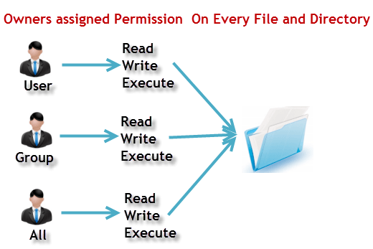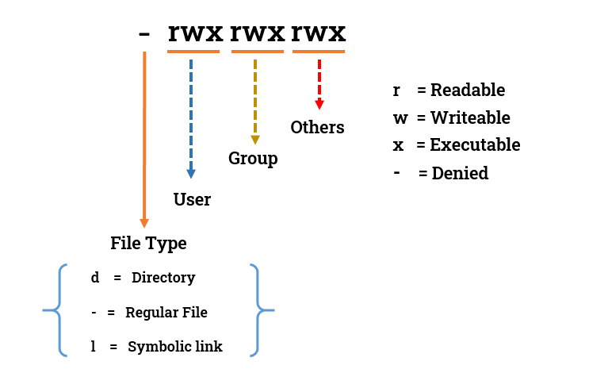

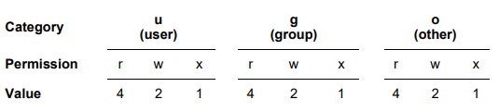

**Typical file permissions**

